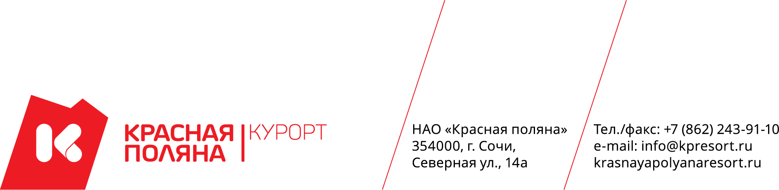

NOTICE
on the procedure for the commercial offers collecting
Dear partners,
Herewith we inform you on the procurement in accordance with the enclosed terms of reference. We invite you to participate in the procurement and send your offers. Please find below the relevant information
1. | Name,  location,  mailing address,  E-mail address,  the Customer’s contact  phone number | Non-public joint-stock company “Krasnaya Polyana” (NJSC “Krasnaya Polyana”)  Legal address: 354000, Sochi city, st. North 14A.  E-mail address: zakupki@kpresort.ru  Location: 354392, Krasnodar region, Sochi, Adler district village Esto-sadok, Vremena Goda embankment 11, Apart-hotel 42004, building 42, entrance 2.  Contact phone: +7 (928) 233-19-49.  Business hours: from 9:00 am to 06:00 pm, lunch break from 01:00 pm to 02:00 pm, on pre-holiday days - from 9:00 am to 05:00 pm, lunch break from 01:00 pm to 02:00 pm.  Contact phone number for communication in case of problems during registration / problems during submitting a commercial offer on the website: 8 (938) 400-55-05
2. | Subject of the contract | Supply of equipment, execution of works on installation and “turnkey” adjustment of technological equipment with a capacity of 3600 hl / year of a restaurant-brewery – the IInd stage of the object: “Recreation and entertainment complex”, located at the address: Krasnodar region, Sochi, Adler district, village Esto-Sadok, northern slope of the Aibga ridge, elevation point (spot height) +960
4. | The procedure for submitting applications for participation in the qualifying casting of the bidders | The commercial offer for participation in the procurement shall be submitted by sending of the commercial offer to the Customer's website via Internet (http://www.tender.gorkygorod.ru/), to the “Procurements” section.  Deadline for the offers submitting:  Date and time: the 20th of August, 2020, at 02:00 pm.
5. | Place and date of consideration of the participants’ offers | The participants’ offers will be considered at: 354392, Krasnodar region, Sochi, Adler district village Esto-sadok, Vremena Goda embankment 11, Apart-hotel 42004, building 42, entrance 2.  Date and time: the 20th of August, 2020, at 04:00 pm.
This procedure is not an auction or a public tender. It is not a public offer, it is not regulated by Articles 447-449 of Part one of the Civil Code of the Russian Federation and Articles 1057-1061 of Part two of the Civil Code of the Russian Federation respectively, and does not impose obligations established by the above-specified Articles of the Civil Code of the Russian Federation, including the obligatory conclusion of a contract

